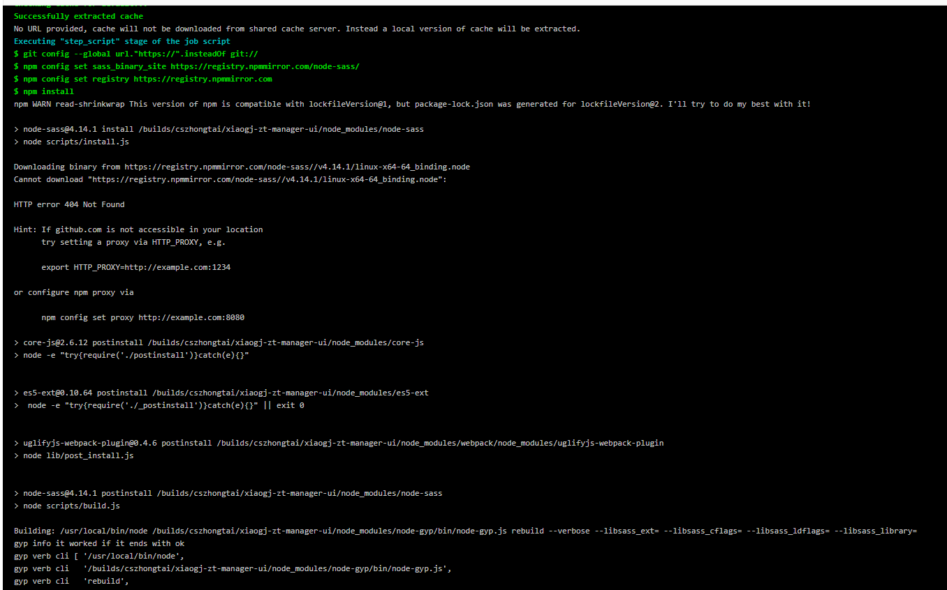

网络原因下载github包失败

https://github.com/sass/node-sass/releases/download/v4.14.1/linux-x64-64_binding.node

Downloading binary from https://registry.npmmirror.com/node-sass//v4.14.1/linux-x64-64_binding.node  
Cannot download "https://registry.npmmirror.com/node-sass//v4.14.1/linux-x64-64_binding.node":

排查，更换镜像地址， 更换sass，都不行

最后把包下载到自己能访问的cdn，下载